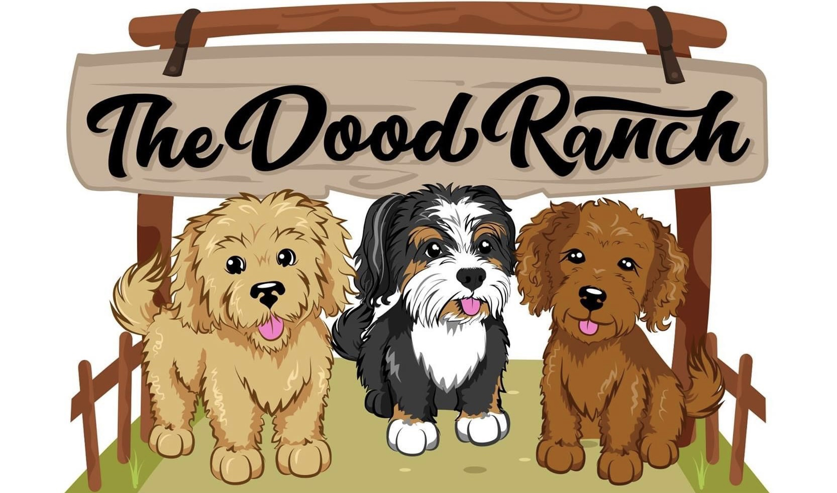
Puppy Contract
Seller: Dana Wilson
Buyer: XXXXX XXXXX

Breed XXXXX
Litter XXXXX
Color XXXXX
DOB XXXXX
Gender XXXXX

Price $ XXXX Non-Ref Deposit $ 400 = Due at Pick Up $ XXXX Cash ONLY! No electronic payments will be accepted as payment on the day of pick up. Electronic payments are for deposits ONLY! The only exception to this rule is if you are an out of state buyer not picking up in person. If puppy is being shipped remaining balance is due 24 hours prior to shipping date.
Sales Agreement may be sent and approved by email without physical signature – Buyer may also approve by text, messenger, or another electronic method. By sending a deposit, Buyer agrees with the terms and contents of the Agreement as sent – and is a legal and binding acceptance.

Deposit is typically 25% of the total price of Puppy, or minimum $300. The deposit amount due can vary from Buyer to Buyer, to Puppy. (See above deposit due.) Deposits are non-refundable except in the event of the death of Puppy prior to pick up, or any other event which makes Puppy unable to be collected/delivered to Buyer, unforeseen events (weather, health, etc) for more than 3 weeks after the schedule date.

Included: Puppy will have all shots (plus dewormings every 2, 4, 6, 8 weeks) as age applicable at the age of Puppy at the time of placement with Buyer. Puppy will be ready to go home no earlier than 8 weeks of age. For every week puppy is held past the scheduled pick-up date, Buyer may be responsible for additional shots, dewormings, and food costs. A per day charge of $5-$10 per day past 8 weeks of age will be assessed if postponement is due to Buyer’s delay – unless other written arrangements have been made.

Health Guarantee: Genetic guarantee is in effect until Puppy reaches 12 months of age. Seller makes every possible effort to deliver a healthy, pet quality puppy. Puppy is not sold as a “show”, “competition” or “breeding” dog unless expressly stated in this agreement. Due to the unpredictability of natural causes in living animals, it is reasonable to limit the health guarantee to terms and conditions as outlined below.
If Puppy is found to have an irreversible genetic defect that will ultimately cause its death and cannot be treated, or a health condition resulting in death (not to include viruses or infections), Seller will replace Puppy with a puppy of equal value, provided the Buyer returns Puppy (upon request), all registration papers, and vet findings in writing, within 24 hours of findings. Seller retains the right to have the puppy re-examined by a vet of choice. Seller shall not be responsible for any additional expenses not specified in this agreement. No refunds given unless expressed herein.

Buyer is given 48 hours, from the delivery date to take Puppy to a licensed veterinarian for health check. No puppy is guaranteed to be parasite or protozoal free (to include eggs or live parasites) after initial 48 hours. If Puppy is found to have said issue(s) during the 48hr period, Seller will reimburse Buyer the cost of the anti-parasitic/anti-protozoal medicine only. Seller does not reimburse for the required vet exam or tests. Puppy is also not guaranteed against future coccidia, hernias, hypoglycemia, parvo, thin/improper coat, improper bite, kennel cough, ability to breed, to include testicle descension, or any condition that can be treated by a veterinarian – this includes behavior Buyer deems bothersome or unacceptable (e.g. barking, chewing, inability to get along with other dogs).
Dispute(s) or Disagreement(s): Seller and Buyer both agree that in the rare instance of a disagreement between the parties, the situation will not be discussed on social media, public groups online (Craigslist, Facebook, etc). While parties are free to discuss privately outside of social media or with legal counsel, any public and/or online discussion will be considered a violation resulting in a fee of no less than $500 per posting/comment, or up to recoverable amount in Libel/Slander suit – this is to protect the reputation of both Seller and Buyer. All issues will either be privately resolved or taken to an arbitrator (or a court of law) at the expense of the party with the initiating complaint. Legal expenses are the responsibility of the initiating party, unless otherwise decided by a court/arbitrator. Any court hearings and filing must be in the county in which the Seller resides; therefore, this contract is bound and enforced by the laws and codes established in the State of Texas.
Buyer further agrees that this puppy will NEVER be placed with a rescue or shelter but will return the puppy to Seller. If puppy is sold or ownership changes, all parts of this contract must be transferred and upheld by the new owner.

I, (print) , the Buyer, acknowledge that I have read, understand and agree to the terms of this contract and all of its provisions and I, the Buyer certify that I am of legal age and I acknowledge receiving a COPY (paper or electronic) of this sales contract as shown by signing my name below. By signing below, I also acknowledge no refunds are given under any circumstances – however, a transferable credit may be issued based on circumstances.

Buyer Signature_____________________________________ Date _____________

Seller Signature _____Dana Wilson______ Date__XX/XX/XX___

